

Machine Learning for Enhanced Portfolio Optimization

Nino Kokhreidze, Nino Tkemaladze, Dimitri Tkemaladze

Bachelor’s Project Report is submitted for the Economics Program of International School of Economics at Tbilisi State University

Project Supervisor: Shota Natenadze
Tbilisi, 2025

Contents
Contents i
1. Introduction 1
2. Literature review 2
3. Data 3
3.1 Variables 4
3.2 Target Variable 4
4. Methodology 5
4.1. Dataset Overview and Time Series Analysis 5
4.2 Markowitz Mean-Variance Model 6
4.3 Expected Return 9
4.3.1 Tree-based model 9
4.3.2 ARIMA 16
4.4 Volatility Estimator 18
5. Results 19
6. Limitations 21
Appendix 23
References 26

Introduction
Investing in the stock market is a popular way of accumulating wealth and saving money. Increased accessibility and social media influence make trading stocks more appealing nowadays and an increasing number of individuals and companies are highly concerned about their portfolio allocation. Investors frequently reallocate their savings from conservative bank deposits to stocks to pursue higher returns. Some find it a source of interesting hobbies and entertainment, while others consider it a serious matter. The stock market can be modeled as a dynamic, incomplete information game. Stock market has a sequential game-like structure, where players react to others past actions and public signaling, making it a dynamic and strategic environment.
Stocks empirically show higher long-term return compared to other sources of assets, such as real estate and savings accounts. However, potential extra gains come with riskier asset allocation. The risk-return tradeoff makes it hard to maintain the stability and growth of the financial assets. In addition, the unpredictable manner of stock prices makes this process much more complicated and difficult. Like other financial assets, stock prices are affected by macroeconomic variables, past prices and overall economic and industrial health. The drawback is that this market can be easily speculated and prices could artificially fluctuate, even the announcement of the entrepreneur can affect the price. Fraudulent activities such as insider trading, pump and dump, etc. manipulate the market and create inefficiencies. In the modern digital age information flows with the speed of light and everything quickly impacts stock prices. This creates the need for more comprehensive investigation, such as news and articles sentiment analysis.
Markowitz modern portfolio theory is a traditional tool, which is still frequently used for building diversified portfolios. This approach assigns weights by maximizing average returns given pre-defined risk constraints. The main disadvantage of this method is that prices are highly volatile and using historical average returns give inaccurate estimates. Despite accuracy not being the main goal, there is still a gap for improvement to build a more optimal portfolio. On the other hand, supporters of the efficient market hypothesis might claim that everything is already captured in historical price and no further investigation is needed, hence from their point of view Markowitz gives the most optimal solution.
The main objective of the project is to study the behavior of financial markets and challenge the efficient market hypothesis (EMH) and Random Walk Theory through improvement of the Markowitz optimization algorithm with replacing average values by predicted stock prices and risk by comprehensive volatility measures using shrinkage estimators. EMH assumes that markets efficiently incorporate all available public information, therefore investors cannot consistently outperform the market as all relevant updates are already reflected in current prices. Stock prices accurately reflect available data and respond rapidly to new information as soon as it becomes available. Random walk Theory states that stock prices cannot be predicted and take a random path. It is defined as a process where the current value of a price is composed of past value plus error term defined as white normal (with zero mean and constant variance).
$P_{t}$ = $P_{t - 1} + ε_{t}$ (1)
This theory suggests that if stock prices are really efficient, then any change from day to day has to be due to the news and news is essentially unforecastable. Therefore, stock prices have to do a random walk though time and the expected value of future prices equals the current price, making it the best unbiased predictor.
Consequently, neither technical nor fundamental analysis can guess future trends, however if this assumption is violated it could create exploitable opportunities. Hence, this paper aims to prove that the great tandem of the modern portfolio theory and advanced machine learning algorithms can improve the portfolio allocation in short-term settings, such as monthly rebalancing and expanding gains with minimal increase in volatility. Improvement of statistics and development of robust machine learning algorithms help uncover complex patterns of financial data. However, the goal is not to perfectly predict the magnitude of the price but the direction of it. Building a strong and diversified portfolio includes proper stock selection, accurate price prediction and optimization techniques. All the steps will be carefully examined and chosen in this paper.

Literature review
There are several critiques of the Markowitz model. The paper “Analysis of the Limitations of Portfolio Theory” analyzes the assumptions of the MPT and suggests adapting them to reality. He checks the relevance of the assumptions: securities market efficiency, rationality of agents, single investment period and no short selling (Wang, 2023). With the Chinese securities market example, he proves the incompatibility with the law of one price with a 40-100% spread. The potential explanations behind this could be information asymmetry, transaction costs and market manipulation. Even though the solutions are not provided, important points are made and the validity of the assumptions will be reviewed while selecting the assets for future analysis.
The paper “Limitations of portfolio diversification through fat tails of the return Distributions: Some empirical evidence” also reviews the limitations of diversification and the modern portfolio theory (Eom, Kaizoji, Livan, & Scalas, 2020). This article empirically proves the problems of flat tails associated with diversification. Increasing the number of assets mitigates large gains, but it does not guarantee a decrease in large losses. This could be due to the systematic risk which is affecting the entire market. A possible solution could be replacing the covariance matrix with a shrinkage estimator, which will be incorporated in the optimization framework.
There are alternative machine learning algorithms suggested for optimization in the paper “Interpretable Machine Learning for Diversified Portfolio Construction” (Jaeger, Krügel, Marinelli, Papenbrock, & Schwendner, 2020). In this paper, the hierarchical risk parity (HRP) and equal risk contribution (ERC) methods are compared and the superiority of the former is proved with the explainable AI. HRP does not suffer from Markowitz curse (increased covariance matrix instability with higher diversification) because of no direct matrix inversion, more robust estimations and natural diversification through clustering. This method therefore outperforms Markowitz optimization because of its robustness towards noise. While comparing other advanced methods to Markowitz seems captivating, it is computationally expensive and also out of the scope of this paper. However, this study will try to fill the gaps of Markowitz optimization through robust covariance matrix estimators.
Marquering and Verbeek (2004) demonstrate that even simple and straightforward linear models, such as OLS regressions, can capture meaningful signals in stock returns and volatility. These approaches improve risk-adjusted performance relative to passive strategies, resulting in economic profit. Building on this, the paper “Machine learning portfolio allocation” provides evidence that machine learning models can identify complex, non-linear relationships in data that traditional linear models fail to capture (Pinelis & Ruppert, 2022). This further increases performance and forecasting accuracy. Specifically, the study finds that adopting Random Forest for both return and volatility forecast results in 28% improvement in Sharpe ratio in comparison to a buy-and-hold strategy. This assumption is also confirmed by another study (Gu, Kelly, & Xiu, 2018), which found the benefits of using machine learning for market timing, reporting Sharpe ratio increase of 26% with neural networks and 18% with Random Forest, both outperforming the buy-and-hold strategy.

Data
The paper will build two portfolios to explore the issues of historical price: the first portfolio from individual S&P 500 stocks and the second portfolio from S&P 500 index and T-Bills. For this study, a comprehensive dataset was built encompassing historical stock prices and macroeconomic indicators. Daily stock market data of the S&P 500 index (ticker - SPY’), spanning a four-year period, from January 1, 2021, to April 30, 2025, was obtained through the Tiingo API. The second data was obtained for all individual tickers from S&P 500.

3.1 Variables
The following daily stock information was collected: High, Low, Open, Close, Adjusted close, Volume. To account for broader economic influences on stock performance, macroeconomic data was obtained from the Federal Reserve Economic Data (FRED) database, maintained by the Research division of the Federal Reserve Bank of St. Louis. Macroeconomic indicators incorporated in the analysis include Consumer price index (CPI), Federal Funds Effective Rate, Market Yield on U.S. Treasury Securities at 10-Year Constant Maturity, Market Yield on U.S. Treasury Securities at 2-Year Constant Maturity, CBOE Volatility Index (VIX), Nominal Advanced Foreign Economies U.S. Dollar Index, Unemployment rate, Economic Policy Uncertainty Index and Crude Oil Price (WTI).

3.2 Target Variable
The choice of target variable is not straight-forward while working with financial data. The first choice should be made between predicting price or return, which could be both in percentages or logarithmic function. Both methods have their advantages and disadvantages. The main drawback of price prediction is non-stationarity, which is present in the data as in almost every financial data. The Dickey-Fuller test was conducted on both datasets and it claimed non-stationarity of ‘adjClose’. However, the first difference and return variable successfully passed the test of stationarity. Stationarity assumption is almost always crucial in time series modelling. Additionally, the interpretability of price is harder because of its nominal nature, and additional calculation is needed to obtain return values, which comes with greater errors. Considering the project’s aim to build a portfolio optimization framework, the decision was made on percentage return.
The second choice is about date range. Target is defined as in (2). A 20-day prediction period was selected to dynamically evaluate and update the portfolio weights if essential. For longer period predictions, the training data should be larger. For short-term return prediction daily data of 5 years is sufficient to capture patterns. Comprehensive analysis was further conducted with the help of LightGBM, which solidified the arguments for a 20-day return.

$\frac{P_{t+20}-P_{t}}{P_{t}}$ (2)

Methodology

4.1. Dataset Overview and Time Series Analysis
The examination is carried out on S&P 500 daily data spanning from January 4, 2021 to April 30, 2025 yielding 1086 observations of 20-day forward returns. This period includes significant market volatility including the Covid-19 recovery, surging inflation, FED interest rate hikes, Russia-Ukraine war and geopolitical uncertainty, U.S. economic resilience and recession concerns, providing a robust dataset for predictive modeling.
The mean forward return, 0.995%, indicates positive market trend during this period with the standard deviation of 4.35% showing considerable short-term volatility. However, the negative skewness (-0.42) indicates more extreme negative outliers.
Figure 1 below shows three rolling standard deviations of 20-day forward return calculated using 20-days, 60-days and 120-days windows. All three indicators follow remarkably similar trajectories, but shorter the window, the more sensitive the measure is to short-term fluctuation, while 120 window volatility is smoother.
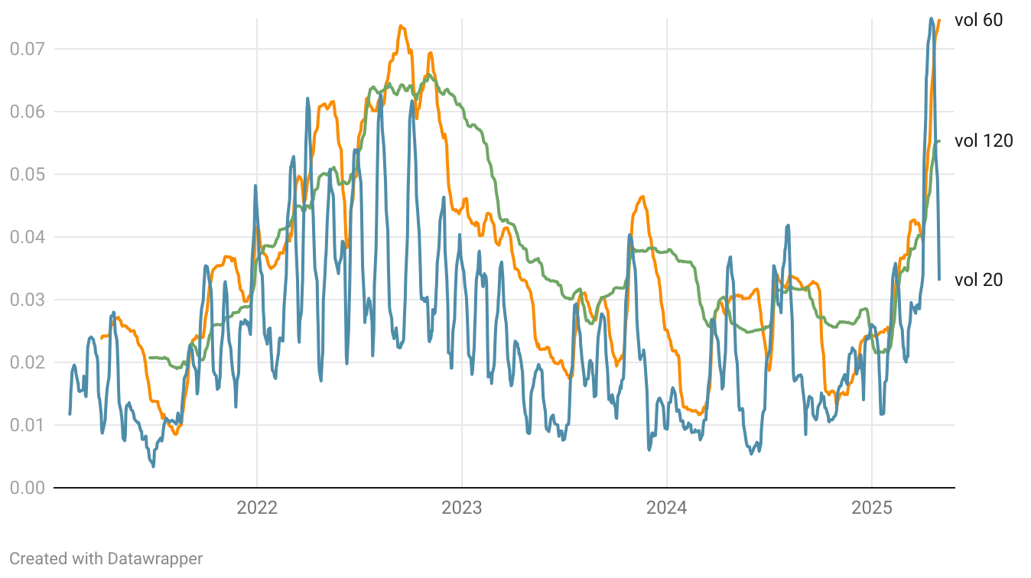
Figure 1: Rolling Volatility Over Time
To assess the behavior of asset prices, different time series analyses were conducted to provide a robust statistical framework. The Augmented Dickey-Fuller (ADF) test for unit roots and random walk behavior in stock prices. The results (statistic = -0.81, p-value = 0.815) fail to reject the null hypothesis of a unit root, providing evidence for non-stationary price behavior ($H_{0}$: $ρ$ = 1). While this aligns with the random walk hypothesis, it does not definitely establish pure random walk behavior. In contrast, the 20-day forward returns demonstrate stationarity. The ADF test showed statistic of -5.26 with p-value < 0.001 rejecting the null hypothesis and Kwiatkowski–Phillips–Schmidt–Shin (KPSS) test with Statistic = 0.13 and p-value = 0.1 failing to reject the null hypothesis of stationarity. The double confirmation establishes that while prices are non-stationary, the forward returns are stationary, making them suitable for machine learning applications.
Understanding patterns helps identify if there are repeating patterns or trends in time series data. To analyze how predictable returns are, an autocorrelation test was used with the Ljung-Box test to understand if returns behave like white noise.
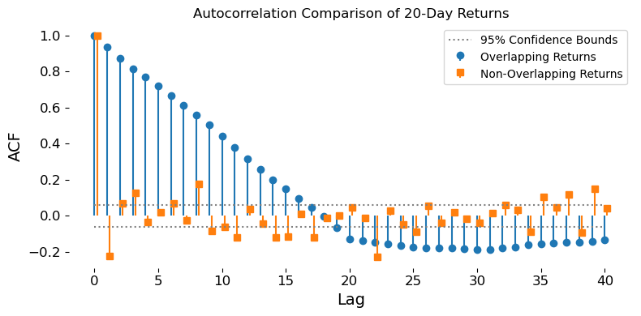
Figure 2: ACF Comparison: Overlapping VS Non-Overlapping
A two-step diagnosis for autocorrelation in 20-day forward returns was implemented. First, it finds significant autocorrelations in the raw overlapping returns. Then it removes the overlap by sampling every 20th return and re-tests for autocorrelation on this independent subset.
The analysis reveals high serial correlation in the overlapping returns. Ljung-Box test with p-values ≈ 0 rejecting the white noise hypothesis. To isolate the artificial correlation induced by overlapping periods, non-overlapping 20-day returns were examined. With sample size 54 observations, the Ljung-Box test resulted in p-value = 0.9, autocorrelations are substantially reduced and not statistically significant. The resulting analysis concludes that observed “persistence” in 20-day returns is just a statistical mirage caused by overlapping intervals.

4.2 Markowitz Mean-Variance Model
The core methodology of the paper’s portfolio optimization framework builds on Markowitz mean-variance model (MV) and consists of several pre-optimization steps: calculation of expected return, estimation of robust covariance matrix.

The modern portfolio theory is based on Markowitz mean-variance model. The setup is simple; weights are assigned to each stock so that expected return of the portfolio is maximized subject to expected risk constraint. The optimization could also minimize the volatility given expected return. Modern analysis frequently criticizes this model for being too simple and not realistic. The purpose of the paper is also to increase the accurateness of the framework.
PyPortfolioOpt library incorporates mean-variance model foundations, but gives ability to provide the model with extensions, such as covariance matrix shrinkage estimator, optimization with Sharpe ratio, adding L2 regularization to the objective function to decrease the number of zero weights, etc.
Traditional Markowitz model uses only the average and covariance matrix of historical returns with predetermined date frequency. The figure represents the result for 20-day frequency. Only several tickers show small covariance, this could be due to good stock selection techniques, which will lead to a diversified portfolio.
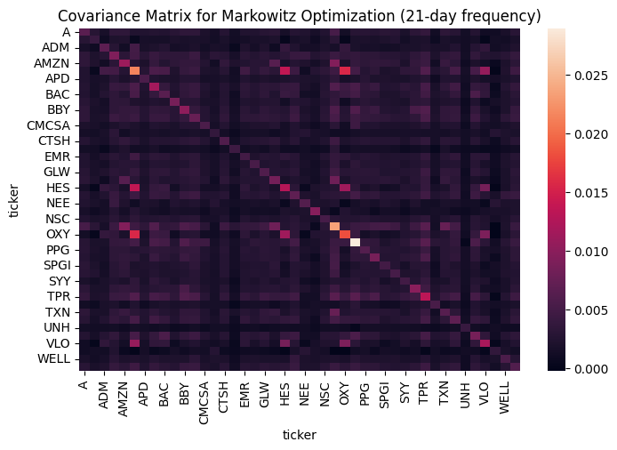
Figure 3: Covariance Matrix (20-days frequency)
The baseline portfolio was built solely based on the Markowitz optimization. Algorithm 1 gives instructions for a full cycle of optimization. Considering the 20-day return target, frequency of calculating mean and covariance is set to 20 days. Several assumptions are made for simplicity: no transaction costs, after rebalancing full return is reinvested and for evaluation purposes the portfolio is built once every month on the first trading day.

Algorithm 1: Rolling Minimum-Volatility Portfolio Optimization
given time-indexed price data $\{t_{1}, t_{2}, …,t_{N} \}$
given test dates $\{t_{1}, t_{2}, …,t_{T} \}$
given rebalancing frequency
for each date $t ϵ \left\{t_{1}, t_{2}, …,t_{T} \right\}$ do:
Estimate expected returns $μ_{t}$ using past data $\{t_{1}, t_{2}, …,t_{N+t-1} \}$ with predetermined frequency
Estimate covariance matrix $Σ_{t}$ using past data $\{t_{1}, t_{2}, …,t_{N+t-1} \}$with predetermined frequency
Solve:
minimize $w^{T}Σ_{t}w$
subject to $\sum{w_{i}}=1, w_{i}≥0$
Store optimal weights $w_{i}$

This algorithm will also be used to calculate the portfolio performance of expected return optimization with machine learning models. However, with a little twist, instead of calculating the mean the predicted returns will be fed into the Markowitz model.
The final results of the baseline Markowitz model are shown in figure 1. Which will be later compared to the tree-based, ARIMA and covariance matrix estimator models. Total yearly return is 8.91% with traditional Markowitz optimization and monthly rebalancing technique.
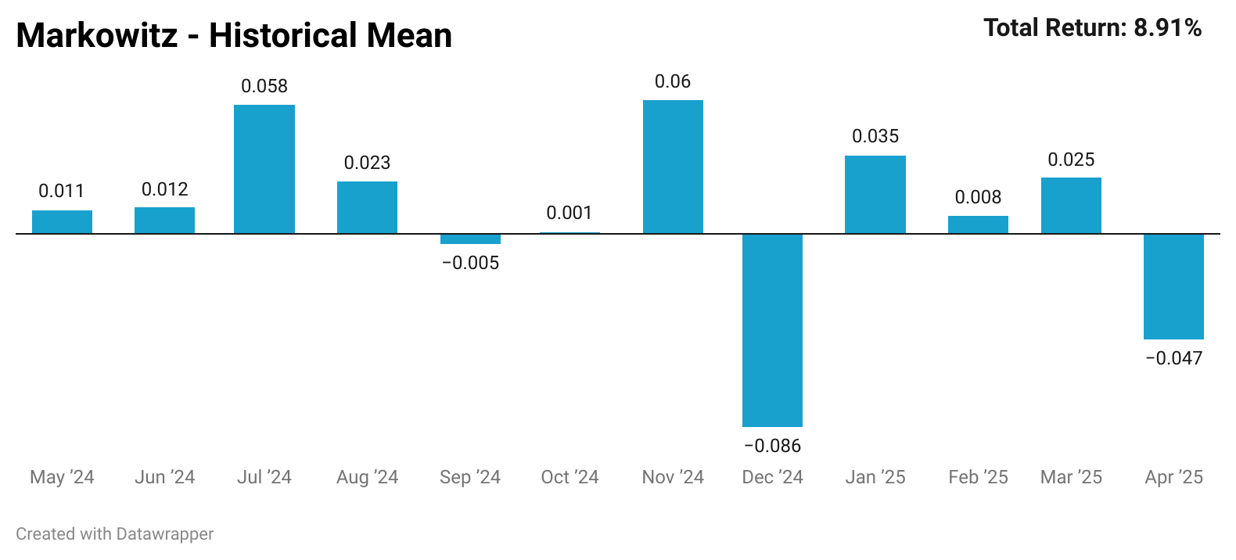
Figure 4: MV monthly returns

4.3 Expected Return
The main drawback of Markowitz model is considering mean as expected return. In the paper tree-based models and ARIMA were tried to improve the prediction accuracy. Since the goal is to improve the portfolio quality, more emphasis will be made on directional accuracy than other metrics. Because Markowitz works in a way that it will assign much less weight if the predicted return is negative, the optimization algorithm could still work effectively if residuals are large but the direction is correct. However, the task could not be modeled as a classification problem, because Markowitz needs predicted return to allocate weights accordingly.

4.3.1 Tree-based model
The methodology employed consists of several key steps. These steps ensure the integrity and validity of the data for subsequent analysis and model development. The study employs two primary datasets: S&P 500 price data, solely to index-level, and macroeconomic indicators. All datasets were aligned to a daily frequency using forward-fill methodology for macroeconomic variables that report monthly or yearly. The analysis period was restricted to January 1, 2021, through April 30, 2025.
To prevent data leakage and ensure realistic trading conditions, as sometimes there are publication delays and data are published later, all input features were lagged by one period. Feature engineering was implemented in the next stage. Trend indicators, momentum indicators, volatility measures, volume analysis, and return-based features were constructed to capture different aspects of price momentum. Macroeconomic variables were processed through multiple transformations, including temporal lags derived from macroeconomic indicators. Interaction and regime features were also created. These included cross-asset interactions such as VIX-Yield Interaction and Risk-off Composite (VIX, Dollar index and DGS10), as well as rolling correlations like VIX-Return Correlation (20-day rolling correlation between VIX and returns) and Oil-Return Correlation (20-day rolling correlation between oil prices and returns). To identify market regimes, High Volatility Regime, binary indicator when 20-day volatility exceeds 75th percentile of 60-day distribution, and Bull Market Regime, binary indicator when the 50-day SMA exceeds 200-day SMA, were created.
The feature engineering process creates a comprehensive set of features designed to capture different aspects of market behavior and economic conditions. However, recognizing that models should not be overly complex given that financial data is inherently noisy, a multi-stage feature selection process was implemented to identify the most relevant predictors. The first stage involved identifying and excluding features with zero variance, low standard deviation and with correlation to target below 0.05. In the second stage high correlation between features was addressed through correlation matrix analysis, feature pairs with correlation > 0.95 were further examined and features with higher target correlation were prioritized. This selection process ensured that the most informative features were retained while eliminating variables that could further introduce noise. The results are as follows:

Figure 5: Feature Selection
Since time series data follow a natural order, randomly splitting it into training and testing sets can lead to misleading results. To ensure that the model works well on unseen data, avoid overfitting and simulate real-world conditions where predictions are made using only past data, a walk-forward validation strategy was used. More specifically, an expanding window approach was applied, which creates multiple train-test splits while maintaining time order. This ensures that the model never sees future data during training, making the evaluation more realistic and reliable.
Given the noisy nature of stock market data, an expanding window approach was preferred over a rolling window to help reduce overfitting. As the training window expands over walks, the model learns from more data, which typically improves the consistency of parameter estimates and lowers variance leading to more stable predictions across time. However, this approach involves a bias-variance trade-off: while expanding windows reduce variance and smooth noise, rolling windows are more adaptive to changing market conditions, and expanding windows may introduce bias during regime changes. Given the limited sample period, the benefits of larger training sets were judged to outweigh potential bias from structural changes.

Algorithm 2: Expanding Window Walk-Forward Validation
Given:
- Total number of available data points: $T_{total}$ = 1086 days
- Initial training data N = 252 days (average trading days in a year)
- Test size: T = 20 days
- Retrain frequency: every T = 20 days
for each walk 𝒲 = 0 to $\frac{T_{total}-N}{T}$ do:
- Train set: from start up to N + 𝒲 $×$ T
- Test set: next T days (from N + 𝒲 $×$ T to N + (𝒲 + 1) $×$ T)
Perform hyperparameter tuning for each train data using time-series cross-validation and randomized search with minimization of MAE.
On each walk, compute SHAP values using TreeExplainer, store average absolute SHAP values for feature importance tracking
Predict for each test set and evaluate
Store metrics: MAE, RMSE, $R^{2}$

To determine the optimal prediction horizon, multiple forward-day targets were evaluated on the model. The 20-day forward return was selected as it provides an optimal balance between financial perspective and predictive model accuracy for Markowitz portfolio optimization. From a statistical perspective, the 20-day horizon demonstrates a lower RMSE compared to longer horizons such as 30 days, despite the latter producing a positive R².
At this stage minimizing prediction error is prioritized, as lower RMSE contributes to reliable estimation. Financially, the 20-day timeframe aligns with typical monthly rebalancing cycles, while also allowing better adaptation to changing market conditions.
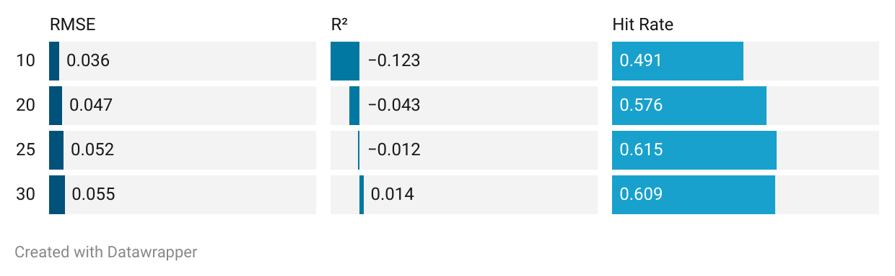Figure 6: Different number of features - Metrics
For each walk-forward step, data was split into training and test sets. feature selection was applied on training data only. Robustscaler was fitted on training data and applied to both training and test sets. Hyperparameter Optimization was performed using TimeSeriesSplit cross validation. LightGBM model was trained on scaled training data with optimized hyperparameters and out-of-sample predictions were generated. Additionally, train and test RMSE were calculated, to control how model overfits.
The simple analysis was performed under top 10 features based on feature importance to choose one model. Four models were compared to each other: Random Forest, Extra Trees, XGBoost, and LightGBM. Despite predictive accuracy not being the main goal and R-squared not being a good measure of performance in tree models, LightGBM was chosen due to the highest R-squared, because the tandem of positive R-squared and high directional accuracy give good results in case of portfolio performance.
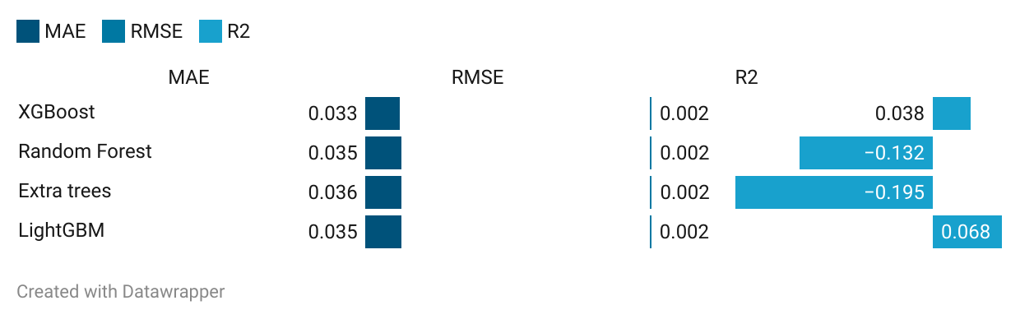
Figure 7: Model Selection - Metrics
Additionally, LightGBM was selected as the primary algorithm due to its effectiveness in handling tabular data with mixed feature types through its gradient boosting framework. The algorithm provides built-in L1 and L2 regularization capabilities to prevent overfitting. RandomizedSearchCV was employed with parameter distributions to optimize model performance. TimeSeriesSplit with 3 folds was used for hyperparameter validation to ensure temporal ordering was preserved during the optimization process. This approach prevents future information from influencing parameter selection.
Even though tree-based models are not affected by scaling, Robustscaler was still chosen, due to some features' value range being in millions while most values were in tenths or decimals. To reduce the impact of the extreme values that could distort the scaling process and negatively affect performance. Scaling parameters were fitted exclusively on training data for each walk-forward window and applied to both training and test sets to prevent data leakage.
To follow feature selection SHAP values were computed to identify most influential features. TreeExplainer was used specifically for LightGBM model interpretation. Average absolute SHAP values were computed across all walk-forward steps to ensure stability and consistency of feature ranking across different time periods. To identify features that are consistently important across different time periods rather than just in aggregation. Features are then filtered based on a minimum frequency and variability threshold to ensure they provide both predictive power and sufficient variation in their contributions across different regimes. This ensures that only features with stable and time-consistent predictive power are selected, enabling model to focus on learning more robust patters.
To evaluate the effectiveness of the models, four standard metrics are used: Root Mean Squared Error (RMSE), Mean Absolute Error (MAE), R-squared and Direction Accuracy (Hit Rate). RMSE was chosen for its ability to penalize larger errors, to evaluate the model’s accuracy in predicting returns, where large deviations can significantly impact decision making. MAE was selected for its interpretability, which helps assess the reliability and consistency of the model’s forecast. While, R² is generally less suitable for financial data modeling, it was included to act as a benchmark, to assess the model's overall fit. Finally, Direction Accuracy (Hit Rate) was chosen to evaluate the model’s ability to correctly predict market direction, which is particularly valuable for portfolio optimization. These metrics collectively show both goodness of fit and prediction accuracy, showing how well the model explains return variation.
First, all features were used for the regression analysis. The results of this feature set are shown in Figure 8.
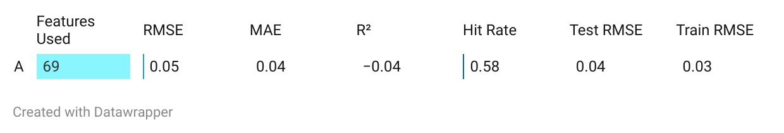
Figure 8: All features metrics
To reduce the complexity of the model, the model was subsequently retrained using different top n most important features based on SHAP analysis to achieve optimal balance between model complexity and predictive performance. Following results was obtained:
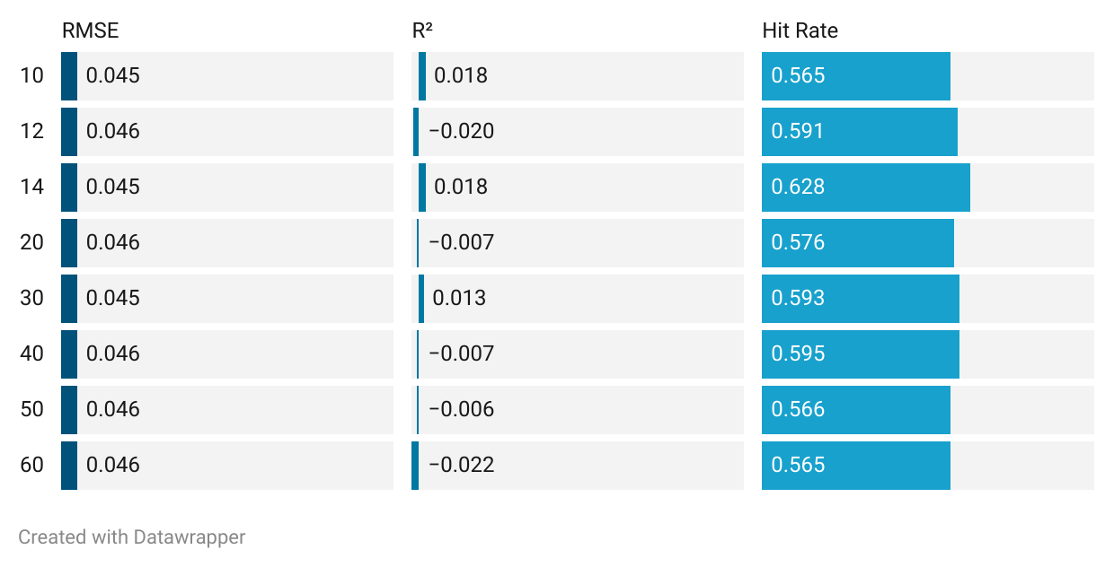
Figure 9: Different number of features (SHAP) - Metrics
The 14-feature model was chosen as it outperforms all others across multiple performance metrics, making it the optimal choice. It achieves the lowest RMSE, while having highest R² and hit rate, indicating it is both the most accurate and reliable model. Importantly, it also shows the small gap between training and test RMSE, demonstrating superior generalization and minimal overfitting. The top 14 features include trend indicators, volatility, monetary policy, macro volatility, oil and volume pressure factors, this covers a well-balanced and diverse set of economic and technical influences, making the model interpretable and economically sound. The model captures essential signals of price discovery and information flow.
The top features identified by the SHAP analysis are consistent with well-established drivers of short-term returns. Technical signals such as the 12-day exponential moving average (EMA), short- vs long-term moving average ratios, and On-Balance Volume (OBV) capture market momentum and investor sentiment, which tend to continue over 20-day windows due to trend-following behavior and gradual information incorporation. Volatility indicators like rolling standard deviation, and Treasury yield volatilities reflect the existing risk regime; rising volatility often signals uncertainty, leading to lower returns as investors shift from risky stocks to safe assets. Macroeconomic factors such as the 20-day average of the federal funds rate, daily policy index volatility, lagged VIX index, moving average of the unemployment rate and lagged oil prices serve as economic drivers, linking to economic forces affecting companies’ profitability. The plot below shows top 14 features with corresponding SHAP values. A more detailed description of the features can be found in the appendix.
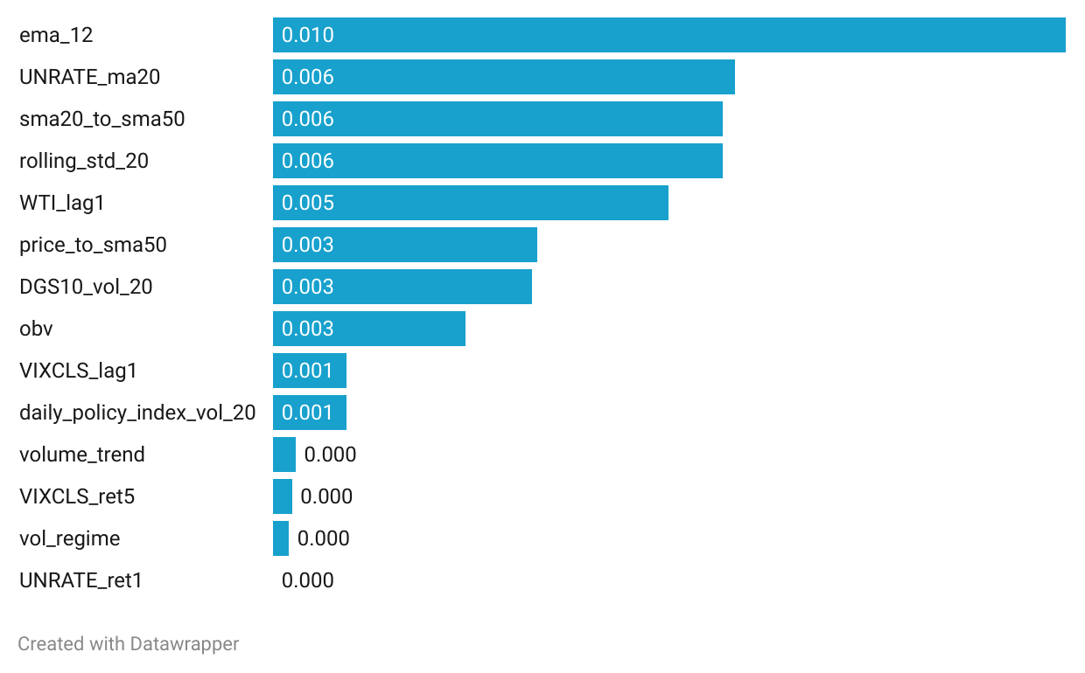
Figure 10: Feature importance (SHAP values)
Collectively, these features provide a coherent and economically intuitive explanation of market conditions. The model's ability to identify these theoretically grounded relationships suggests it is capturing market dynamics rather than spurious correlations, reinforcing the credibility of the predictive framework while acknowledging that such patterns may diminish as markets adapt.
To validate the model’s signal quality and residual structure signal-to-noise ratio (SNR) was calculated. A SNR of 0.187 implies that the variance of the predictions is only 18.7% of the noise variance. In decibels, -7.28B indicates that the noise dominates the signal. While the SNR is low, this is expected in financial return forecasting due to random shocks, behavioral noise and policy/news effects not captured by inputs.
Although the top-14 feature model performs best overall, it still fails the Ljung-Box test of white-noise residual with p-value = 0.00 over 10,20,3 and 40 lags. When tested across 41 walks (lag10), approximately 80% showed p-value < 0.05, meaning significant autocorrelation remains in residuals. This indicates that some temporal dependencies remain unmodeled. However, given the model’s good predictive performance, the study accepts some degree of autocorrelation as a trade-off for generalization.

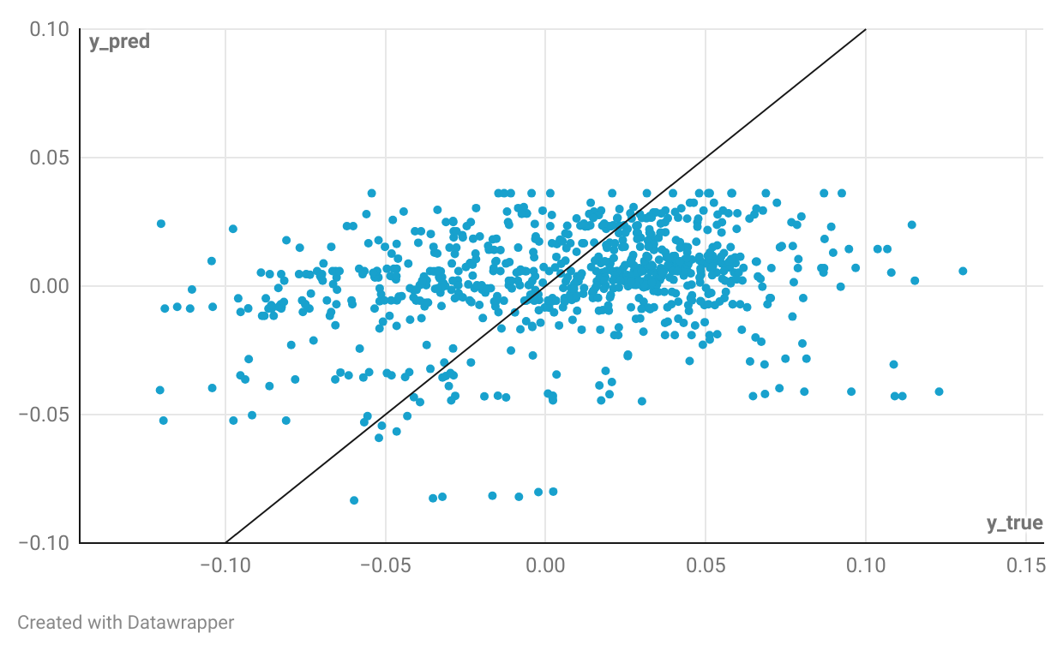
Figure 11: Scatter Plot - LightGBM

4.3.2 ARIMA
Markowitz works better when several assets are provided for optimization, because in case of riskier and risk-free assets (S&P 500 and T-bills), weights are diverging fast from 0 to 1. However, another limitation is training the model as many times as the number of assets. That raises the necessity of testing two main frameworks - building a portfolio with S&P 500 index and T-bills and using LightGBM as a prediction tool and building a portfolio with 44 tickers using ARIMA as prediction tool.
To minimize potential selection bias and generalize the findings across different sectors, four companies from each of eleven different sectors within the S&P 500 index were randomly selected, resulting in a total of 44 stocks for analysis. The stratified sampling approach is used for sector diversification while maintaining a manageable dataset size for efficient analysis. The additional filtering rule about volume and volatility was obtained to use frequently demanded stocks and avoid stagnant assets.
ARIMA is one of the simplest and comprehensive time series frameworks, which is frequently used for stock price or return prediction. It incorporates three essential mechanisms: autoregression, differencing and moving average (Saadeddin, 2025). The model makes assumptions about stationarity, which was already tested.
Fitting the ARIMA model needs three parameters: p,d,q, which respectively represent the number of autoregressive terms, differences and lagged variables. In order to optimally choose the parameters, it is necessary to look at autocorrelation functions in figure 12. Since the biggest increase is for the first lag, q and p will be chosen 1 and since the target value is already somewhat different, d will be set to zero.
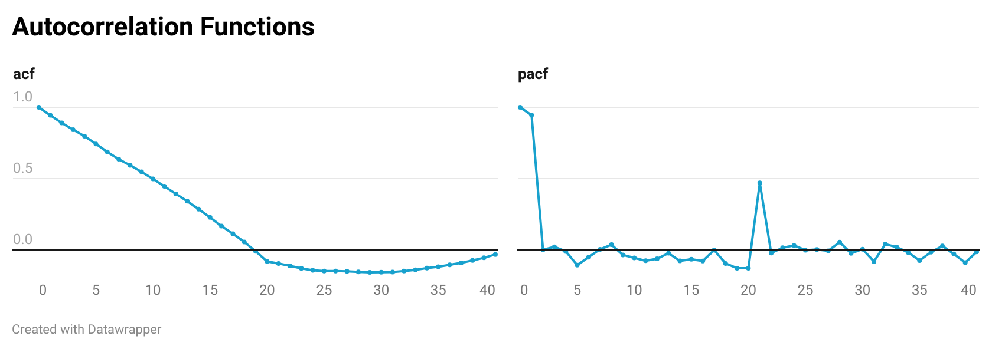
Figure 12: ACF and PACF functions for ARIMA

The predictive power of ARIMA is not exceptionally high. However, directional accuracy is normal especially in financial return prediction. The goal of the paper is not predictive power, it is the performance of the portfolio, which is later investigated.
MAE | RMSE | MAPE | R2 | Dir_accuracy
8.33 | 10.79 | 4538.42 | -0.86 | 0.5
Table 1: ARIMA metrics
Actual and predicted values are plotted against each other in figure 9. The result is quite noisy and scattered, reflecting poor metrics performance. Additionally, Ljung-Box test was performed on residuals for every ticker to test autocorrelation. P-values above 5% for 10 lags indicated no autocorrelation, which increases reliance on the results.
Portfolio with MV + ARIMA framework is optimized as in algorithm 1, but instead of calculating historical return, predicted return is considered. The portfolio with predicted returns show an increase of 1.25% in total yearly return. The general pattern is maintained as in figure 14, but slight improvements in the weights guarantee increase not only in return but in Sharpe ratio from 0.16 to 0.392.

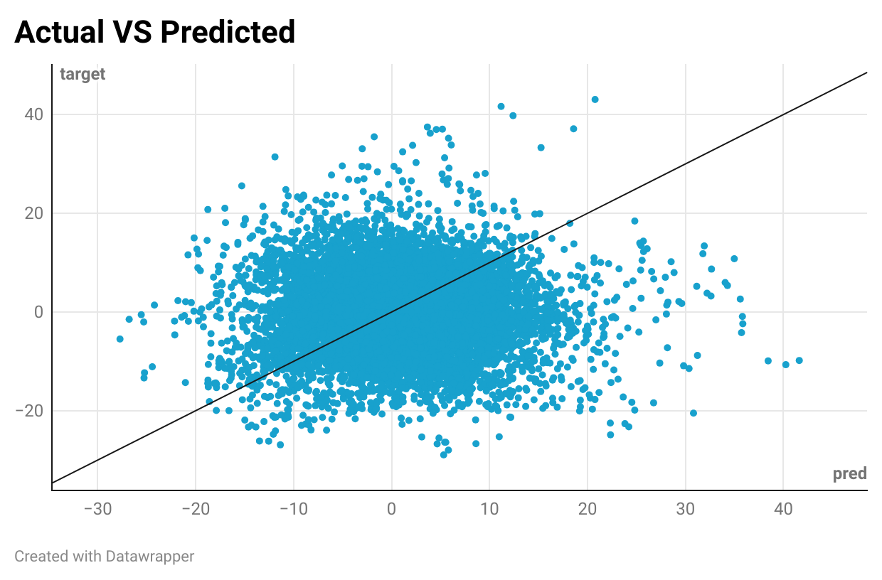
Figure 13: Scatter Plot - ARIMA

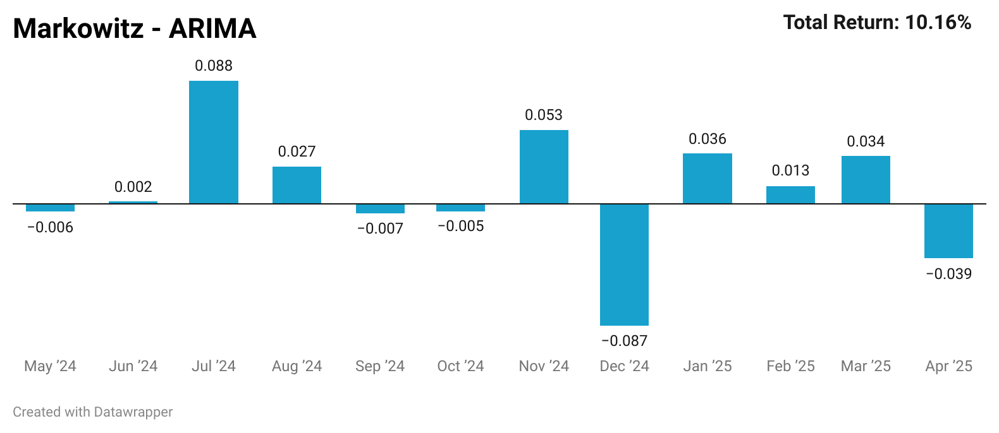
Figure 14: Portfolio monthly returns – ARIMA

4.4 Volatility Estimator
Apart from inaccurate mean estimation, the problem sometimes arises in evaluation of the stock risk. The pitfall of Markowitz in case of covariance matrix raises due to noisiness and might lead to overfitting, because it is unable to capture risk of unseen data. Possible solutions are variations of shrinkage estimators.
PyPortfolioOpt has a built-in shrinkage covariance estimator which deals with noisy structure of the financial data and provides a more robust and stable estimator for covariance matrix. It is estimated as in (3) where $Σ_{target}$ is usually the identity matrix.
$Σ_{shrunk}=\left(1-λ\right)Σ_{sample}+Σ_{target}$ (3)
To evaluate the performance of various shrinkage estimators, it is important to keep other things simple and constant. Therefore, in ordinary (historical mean return model) Markowitz framework covariance matrix is replaced with shrinkage estimator. Overall portfolio returns decreases from 8.91% to 8.58%, which is logical because the shrinkage estimator can evaluate the risk better and the less risky the portfolio the less return it has.
Another variation is Ledoit-Wolf shrinkage estimator, which is also calculated as in (3) but $Σ_{target}$ is a diagonal matrix, where diagonal elements are the average of the sample variances and other elements are zeros. This method also decreases the portfolio return to 8.87%, which balances the trade-off between risk and return better than regular shrinkage estimator.

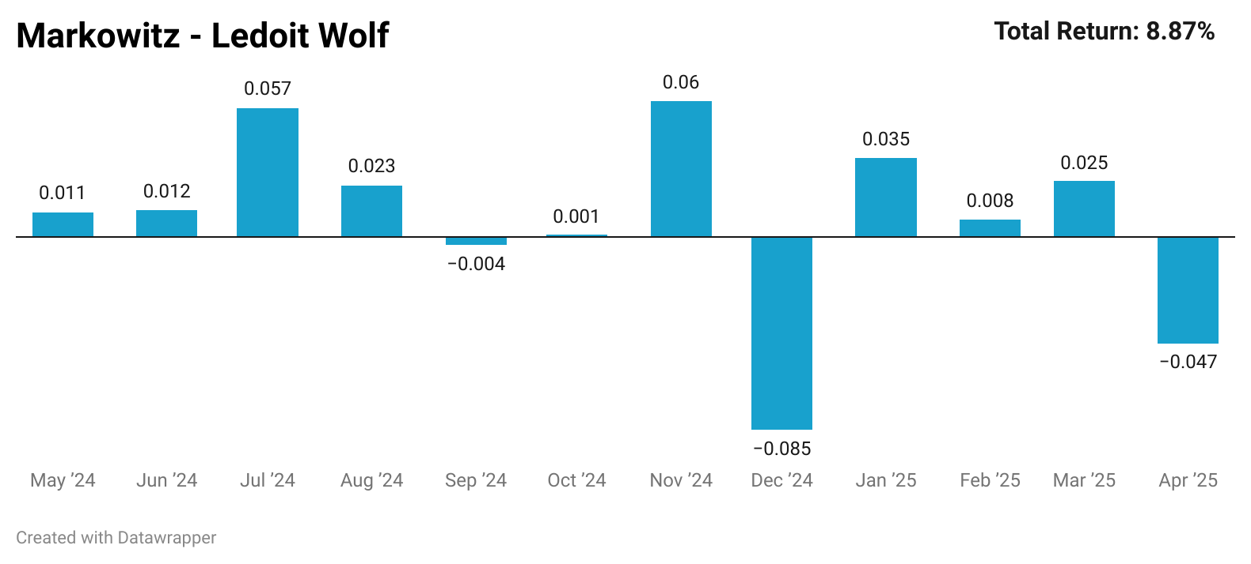
Figure 15: Portfolio monthly returns - Ledoit Wolf

Results
For each of the frameworks in the paper (44 tickers and S&P 500+T-Bills) two portfolios were built, one with regular Markowitz, another with combination of Markowitz and predicted return. The final results are summarized in figure 16. In both settings return and Sharpe ratio are improved slightly, proving the superiority of prediction models. To analyze the performance of the portfolio per month, a weight table is provided in Appendix.
In case of SP500 index data, Markowitz assigns weights to T-bills very close to 1, whenever the predicted return of S&P 500 is negative, replacing the portfolio with risk-free and safe asset. This avoids unsuccessful periods of the stock market. Framework could be oversimplified with assuming no transaction costs and monthly rebalancing techniques, which is frequently present in most financial institutions. In the real market, trading stocks costs money through fees and spreads, and these costs would quickly add up with frequent rebalancing, reducing the actual returns significantly. The paper showed that even the poor performance models can develop a better framework for optimal asset allocation. The poor performance in terms of prediction accuracy claimed once again that forecasting of price is impossible. If that was achievable everyone would take advantage of this feature. The main focus is the direction in which portfolio performance is improved, while incorporating machine learning models. This is true both for diversified and “barbell strategy” portfolios.
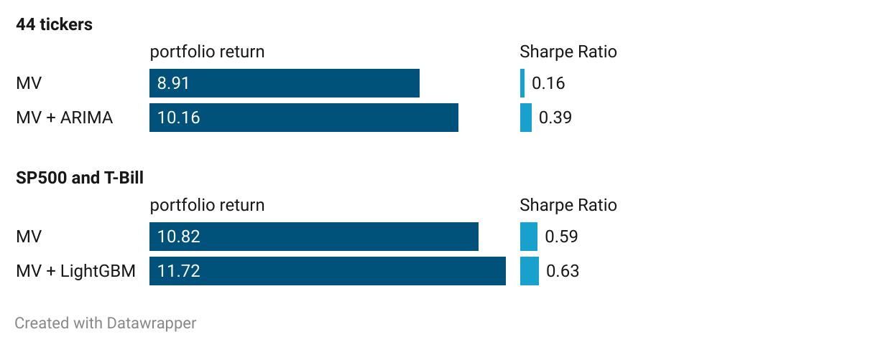
Figure 16: Portfolio Performance

Therefore, out of CM1 and CM2, regular MV is outperformed with machine learning models, while in CM3 shrinkage estimator improved covariance matrix. This claims the initial hypothesis about the gap of improvement in Markowitz by replacing historical mean with predicted returns and covariance matrix with shrinkage estimators. The model’s primary contribution is demonstrating that machine learning can enhance traditional portfolio optimization frameworks, but it is not claiming to have solved the problem of market prediction. The model is able to capture short-term fluctuations with forward-looking behavior, while historical mean lacks this feature.

Comparison Model 1: | MV and tree-based + MV
Comparison Model 2: | MV and ARIMA + MV
Comparison Model 3: | MV and shrinkage +MV
Table 2: Comparison models
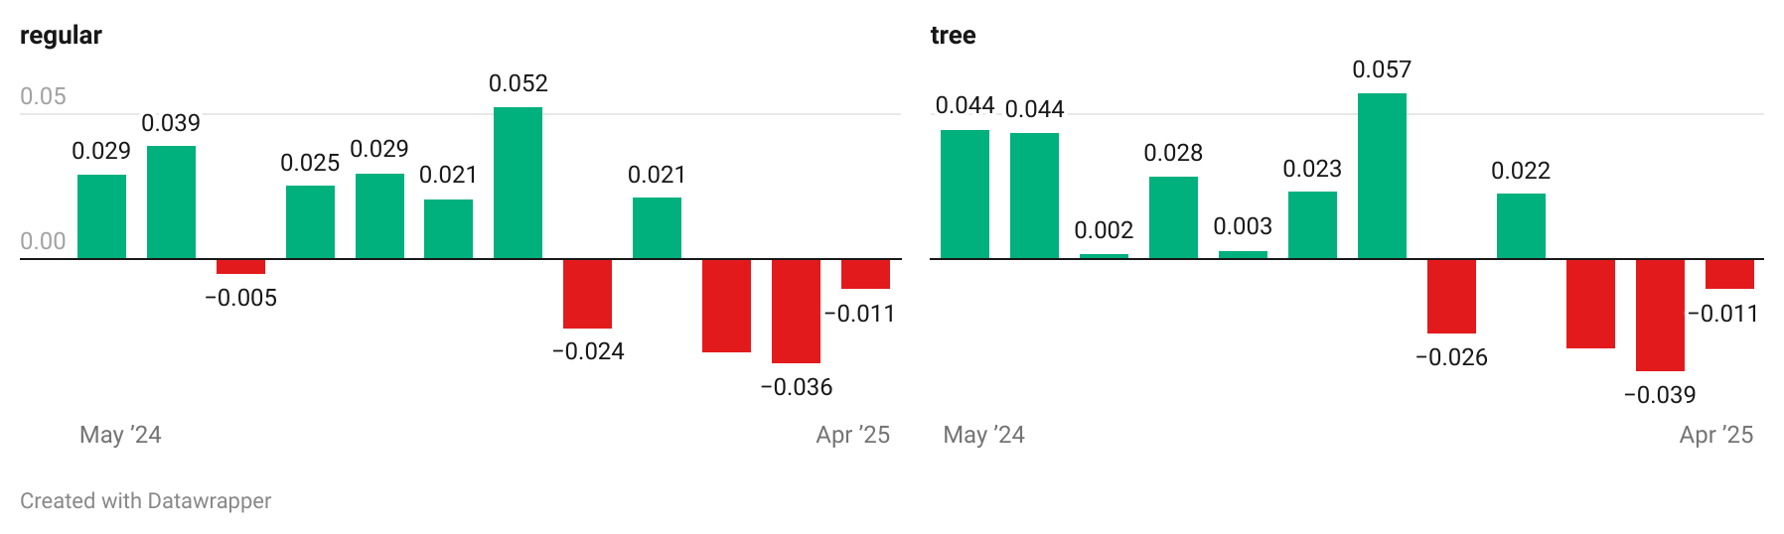
Figure 17: Portfolio monthly returns (MV, MV+LightGBM)

Limitations
Although both ARIMA and LightGBM models may outperform simple historical returns, these models have several inherent limitations when applied to stock market prediction. While the model shows strong performance, these results should be interpreted with caution as they may not be achievable in practice due to market efficiency, transaction costs, and the tendency for predictive patterns to disappear once exploited.
Given the unique characteristics of financial markets, predicted returns face significant practical challenges. Stock markets are susceptible to manipulation and are heavily influenced by human behavior, which is inherently chaotic and exhibits emergent properties due to interacting strategic agents that machine learning models struggle to capture. True market signals are often buried under multiple layers of randomness, making accurate prediction extremely difficult.
Predicting 20-day returns is an unrealistic scenario in practice. If traders could predict future returns with high accuracy, markets would quickly arbitrage away such opportunities through rapid price adjustments. Research confirms this arbitrage effect, McLean and Pontiff (2016) demonstrated that published return-predictive signals lose 35% of their efficacy post-publication. This creates several problems such as slippage, market impact and reactive trading as other traders’ response to these movements further diminish predicted returns.
When multiple ML-based traders act on similar signals, it can cause collective market distortions. This creates feedback loops where the models' own predictions influence market behavior, potentially invalidating the original predictive relationships. (Ng & Mohamed, 2024)
ML models also face significant difficulties in identifying actual market conditions. Traders often use strategic signaling - for example spoofing (placing fake orders to manipulate demand)- which can introduce false patterns that mislead models. There are also interactive effects, every trader’s action influences others, creating a constantly shifting environment of strategic interactions. Unlike traditional ML applications that assume stable feature-outcome relationships, financial data are reflexive and adaptive and patterns disappear once market participants exploit them.
Tree-based models, while powerful, are particularly vulnerable to overfitting historical data in financial contexts unless carefully regularized. This occurs because these models fail to account for the strategic behavior of market participants, making their predictions fragile and potentially obsolete in real-world trading scenarios. The assumption of static relationships between features and outcomes breaks down in the dynamic environment of financial markets.

Appendix

Variable Name | Variable Description
EMA_12 | The 12-day exponential moving average of the asset’s price, a technical indicator that smooths price data by applying higher weight to more recent prices.
UNRATE_ma20 | A 20-day moving average of the unemployment rate.
sma20_to_sma50 | The ratio of the 20-day to the 50-day simple moving average, capturing market trends.
rolling_std_20 | The 20-day rolling standard deviation, indicating market volatility.
WTI_lag1 | Lagged West Texas Intermediate oil prices.
price_to_sma50 | The ratio of current price to the 50-day simple moving average, measuring market positioning.
DGS10_vol_20 | The 20-day volatility of the 10-year Treasury yield, indicating bond market risk.
obv | On-Balance Volume, capturing the flow of volume and its relationship with price changes.
VIXCLS_lag1 | Lagged VIX, representing investor sentiment and market uncertainty.
daily_policy_index_vol_20 | 20-day volatility of the policy index, capturing macroeconomic policy volatility.
volume_trend | A measure of the trend in volume, signaling potential price movements.
VIXCLS_ret5 | 5-day return of the VIX, reflecting short-term market sentiment shifts.
vol_regime | A volatility regime indicator, capturing regime shifts in market volatility.
UNRATE_ret1 | 1-day return of the unemployment rate, indicating short-term labor market dynamics.

Table 3: Variable Descriptions
In table 4 and 5, portfolio weight distribution is summarized, as already stated, whenever the model predicts negative return, Markowitz optimization algorithm fully transfers assets to 1-month T-bills. In reality there are 5 negative return months and the model is able to capture only one of these. Despite 20% accuracy not being the perfect result, historical average can guess none of it. Because on average positive returns balance out negative ones and add up to positive historical average return. Average return might have some financial market information. However, it does not have forward-looking features, which guarantees slight increase in portfolio quality.
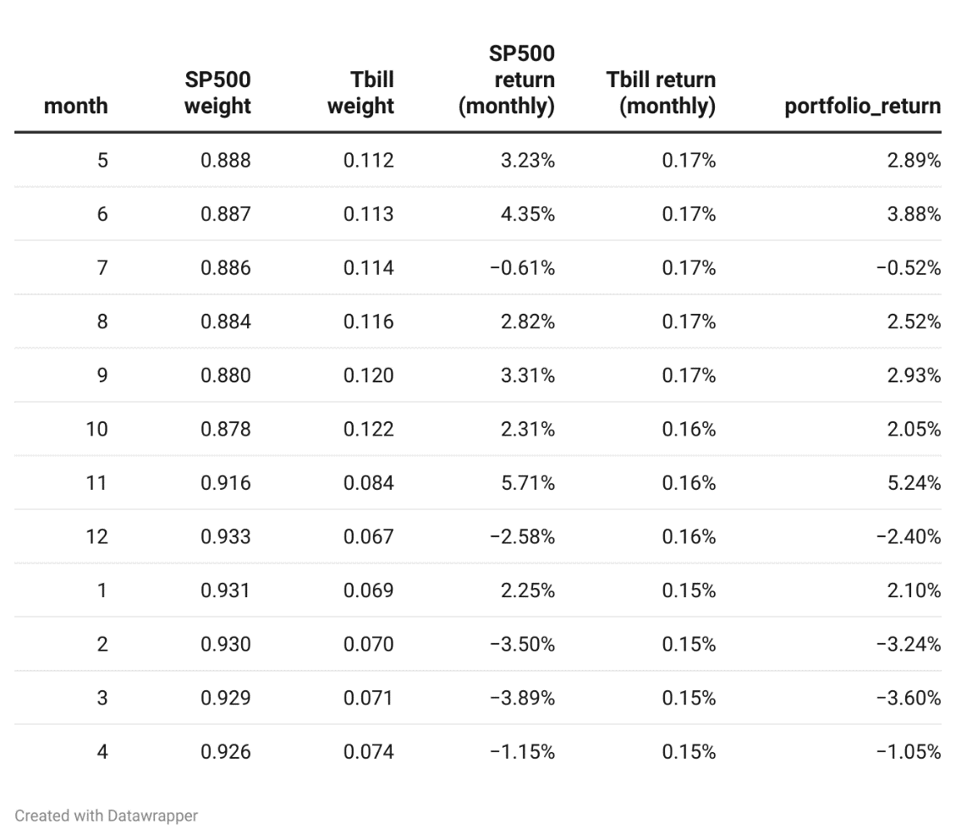
Table 4: Weight table (MV)
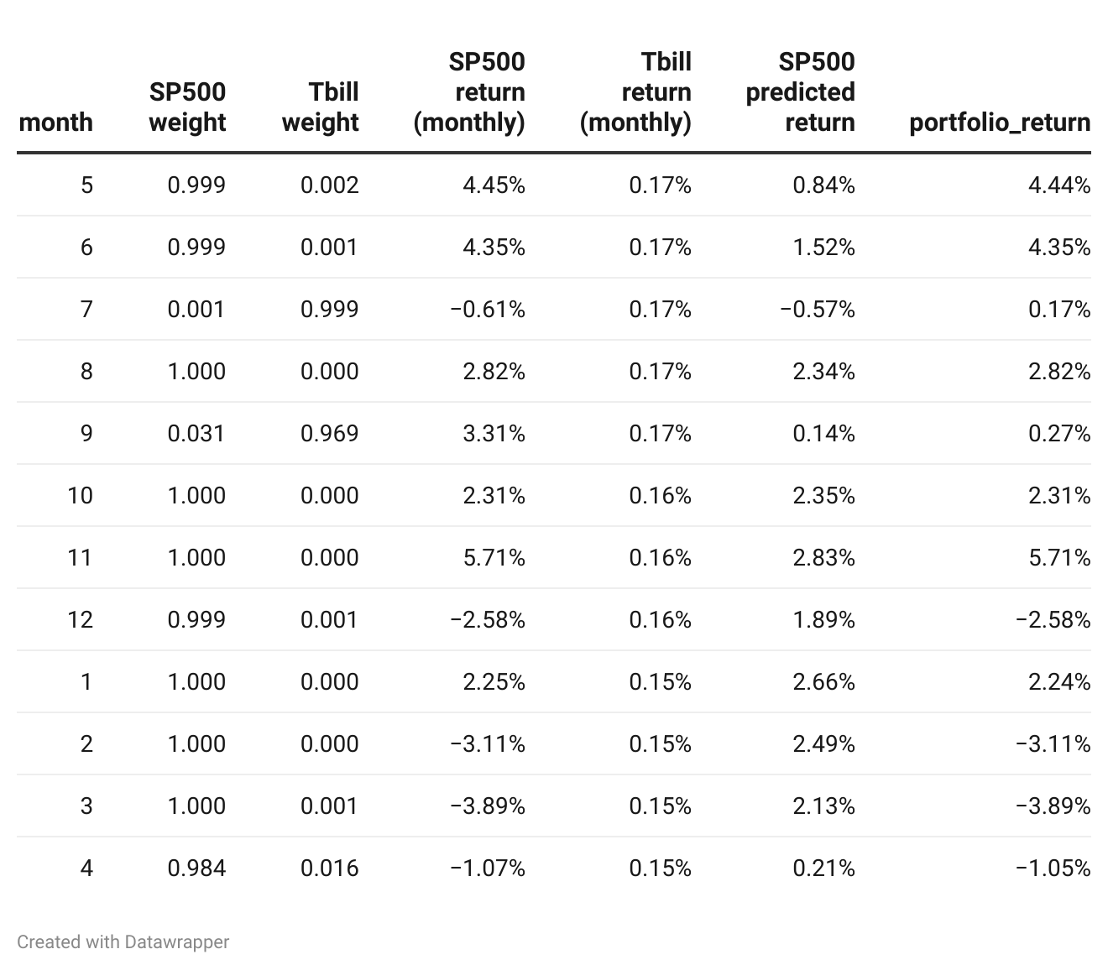
Table 5: Weight table (MV+LightGBM)

References
Abolmakarem, S., Abdi, F., Khalili-Damghani, K., & Didehkhani, H. (2024). A multi-stage machine learning approach for stock price prediction: Engineered and derivative indices. Intelligent Systems with Applications.
Campbell, J. Y., & Thompson, S. B. (2008). Predicting Excess Stock Returns Out of Sample: Can Anything Beat the Historical Average? . The Review of Financial Studies, 1509-1531.
Chaweewanchon, A., & Chaysiri, R. (2022). Markowitz Mean-Variance Portfolio Optimization with. International Journal of Financial Studies.
Eom, C., Kaizoji, T., Livan, G., & Scalas, E. (2020). Limitations of portfolio diversification through fat tails of the return Distributions: Some empirical evidence. North American Journal of Economics and Finance.
Gu, S., Kelly, B., & Xiu, D. (2018). Empirical Asset Pricing via Machine Learning. National Bureau of Economic Research Working Paper Series.
Jaeger, M., Krügel, S., Marinelli, D., Papenbrock, J., & Schwendner, P. (2020). Interpretable Machine Learning for Diversified Portfolio Construction. The Journal of Financial Data Science.
KENTON, W. (2020, October 25). What Is the GARCH Process? How It's Used in Different Forms. Retrieved from Investopedia: https://www.investopedia.com/terms/g/generalalizedautogregressiveconditionalheteroskedasticity.asp#:~:text=The%20generalized%20autoregressive%20conditional%20heteroskedasticity%20(GARCH)%20process%20is%20an%20approach,bonds%2C%20and%20other%20investment%2
LightGBM (Light Gradient Boosting Machine). (2025, March 11). Retrieved from GeeksForGeeks: https://www.geeksforgeeks.org/lightgbm-light-gradient-boosting-machine/
Markowitz, H. (1952). Portfolio Selection. The Journal of Finance, 77-91.
Marquering, W., & Verbeek, M. (2004). The Economic Value of Predicting Stock Index Returns and Volatility. The Journal of Financial and Quantitative Analysis, 407-429.
Pinelis, M., & Ruppert, D. (2022). Machine learning portfolio allocation. The Journal of Finance and Data Science.
Prado, M. L. (2018, September 29). Advances in Financial Machine Learning: Lecture 2/10 (seminar slides). Retrieved from https://ssrn.com/abstract=3257415
Prado, M. L., Simonian, J., Fabozzi, F. A., & Fabozzi, F. J. (2024). Enhancing Markowitz’s portfolio selection paradigm with machine learning. Annals of Operations Research , 319–340.
Saadeddin, Z. (2025, January 7). ARIMA for Time Series Forecasting: A Complete Guide. Retrieved from DataCamp: https://www.datacamp.com/tutorial/arima
Wang, Z. (2023). Analysis of the Limitations of Portfolio Theory. Highlights in Business, Economics and Management.
Ng, L., & Mohamed, Q. (2024, December 17). Artificial intelligence in financial markets: Systemic risk and market abuse concerns. Sidley Austin LLP.
Fama, E. F. (1970). Efficient capital markets: A review of theory and empirical work. The Journal of Finance, 25(2), 383-417.
McLean, R. D., & Pontiff, J. (2016). Does academic research destroy stock return predictability? The Journal of Finance, 71(1), 5-32.

